**Project 3C: Scope Management**

**Report**

screen of execution of example4.kpl

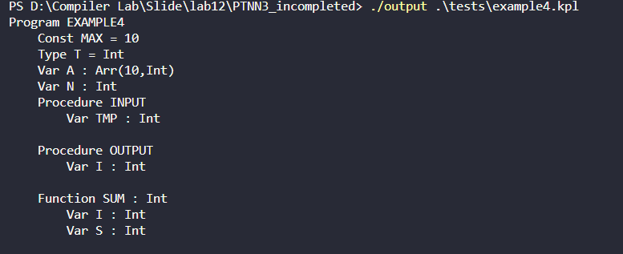

Modify example4.kpl to cause the error: Undeclared variable

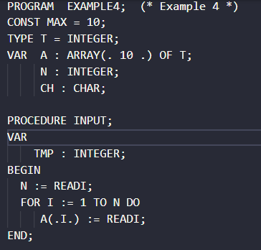

Screen of execution of modified example4.kpl:

